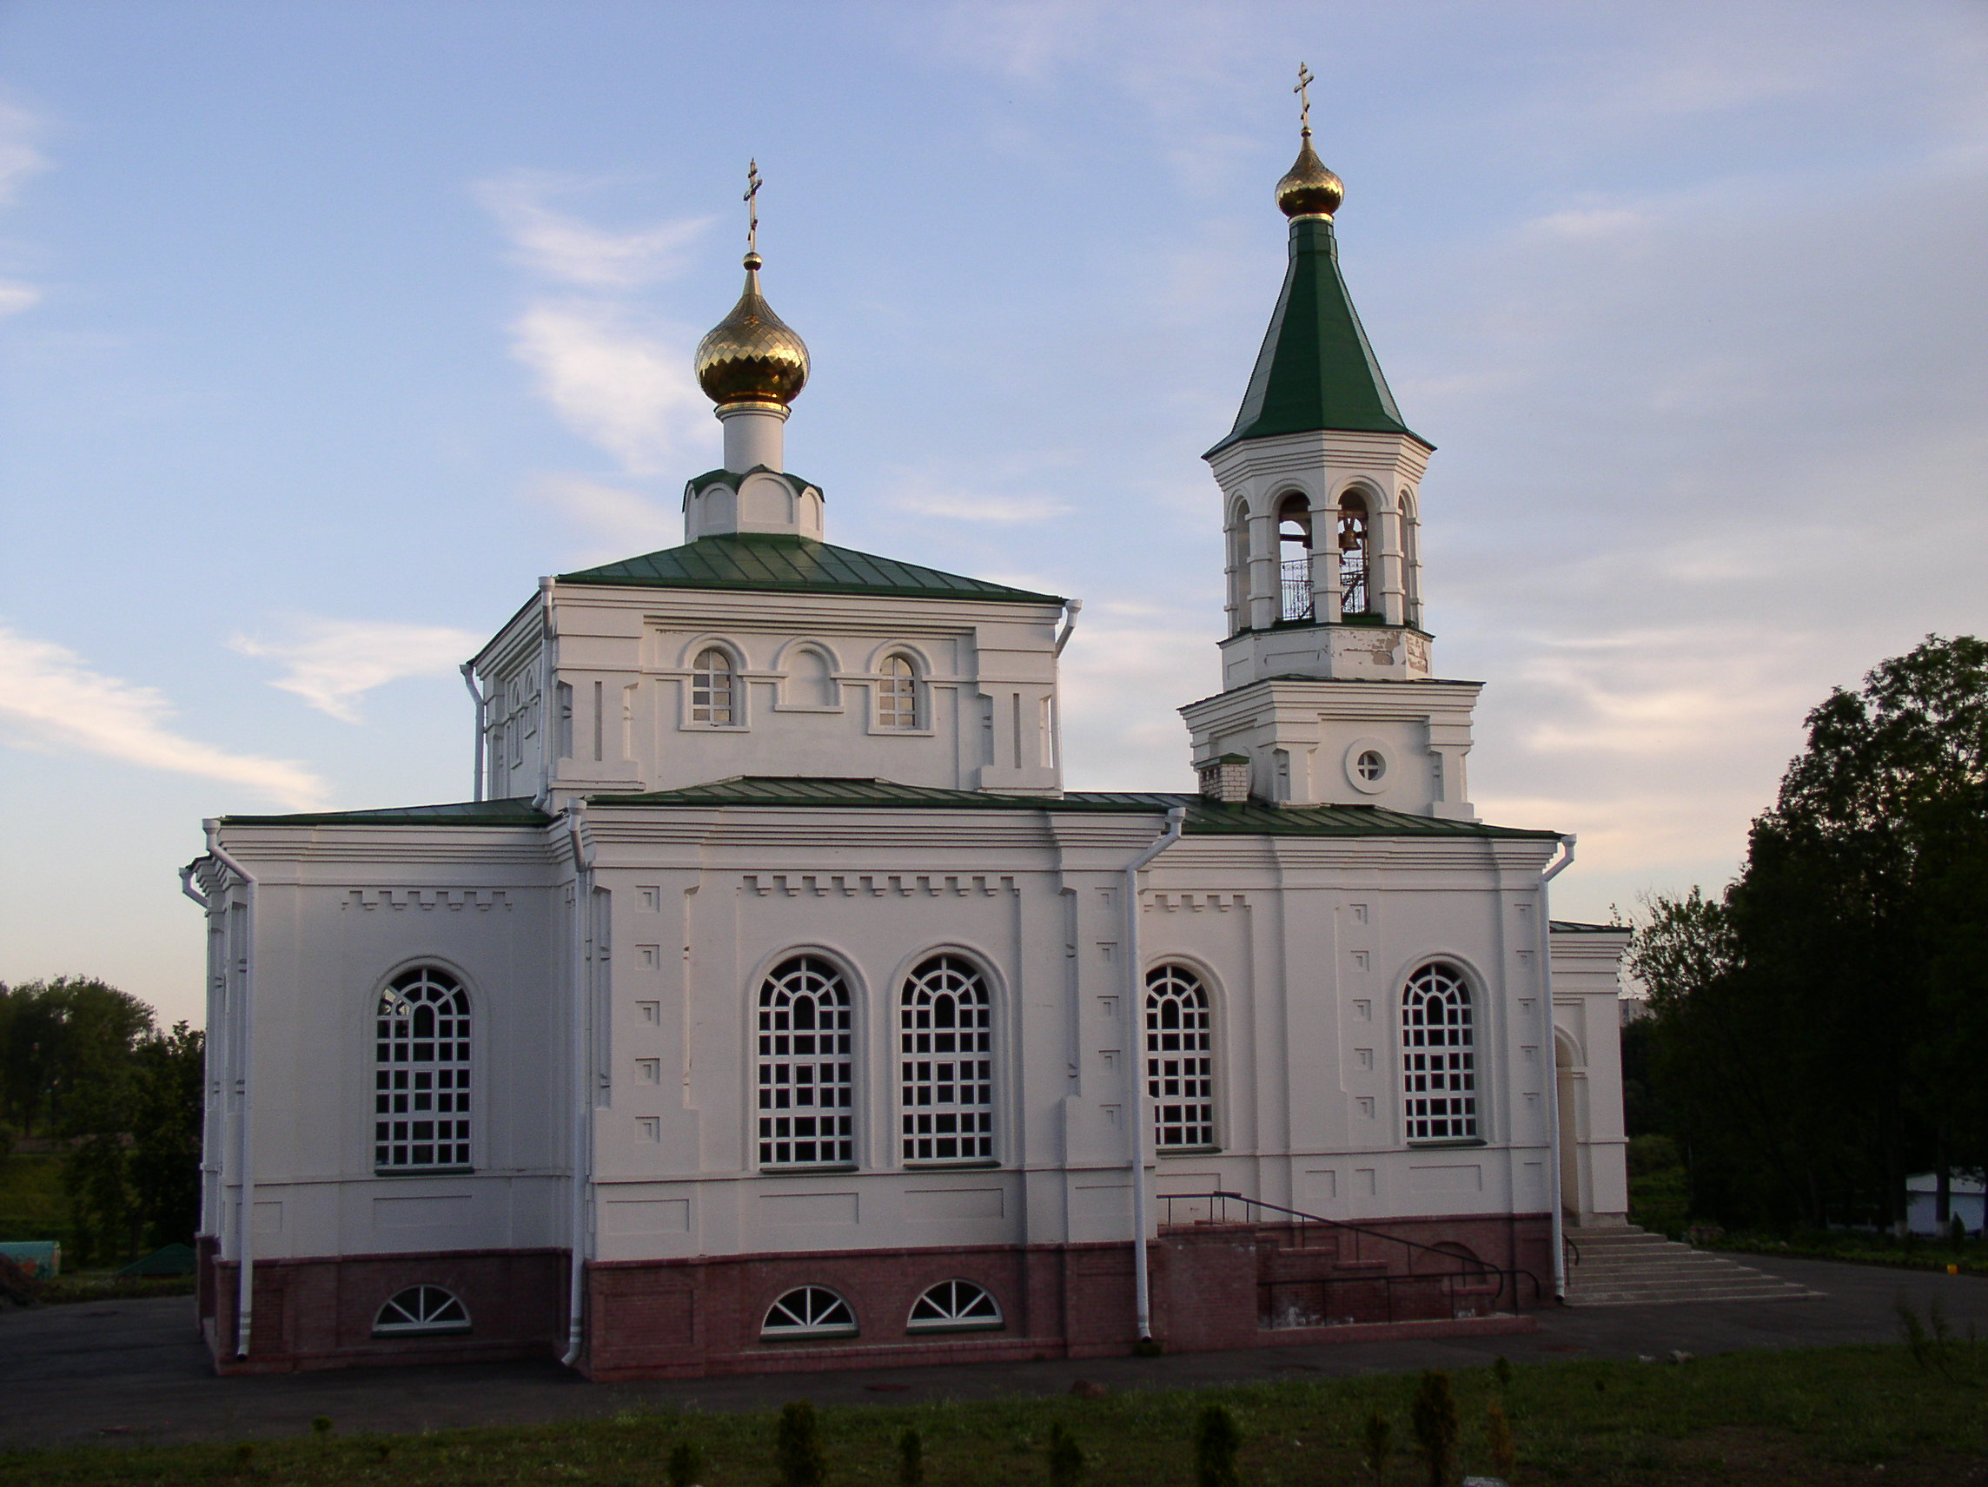
Свято-Покровская церковь, отстроена в 2004 г.
The Protection of the Holy Blessed Virgin Church was build up in 2004

